Lab Experiment: Basic Video Processing Operations
Experiment No: 13
Aim
To capture video from a webcam and perform perspective transformation on each video frame using the OpenCV library in Python.
Tools Required
- Python 3.x
- OpenCV (cv2)
- NumPy
- VS Code / PyCharm / Jupyter Notebook
- Webcam
Procedure
- Install the required libraries:
pip install opencv-python numpy
- Import the required libraries (cv2 and numpy).
- Open the webcam using cv2.VideoCapture(0).
- Capture video frames continuously.
- Define four source points and four destination points.
- Compute the perspective transformation matrix using cv2.getPerspectiveTransform().
- Apply the perspective transformation using cv2.warpPerspective().
- Display both the original video and the transformed video.
- Press Q to stop the program.
Code
import cv2
import numpy as np
# Open webcam
cap = cv2.VideoCapture(0)

while True:
ret, frame = cap.read()
if not ret:
break
h, w = frame.shape[:2]
# Source points (corners of the original image)
pts1 = np.float32([
[50, 50],
[w - 50, 50],
[50, h - 50],
[w - 50, h - 50]
])
# Destination points
pts2 = np.float32([
[0, 0],
[w, 0],
[100, h],
[w - 100, h]
])
# Perspective transformation matrix
matrix = cv2.getPerspectiveTransform(pts1, pts2)
# Apply perspective transformation
transformed = cv2.warpPerspective(frame, matrix, (w, h))
# Display results
cv2.imshow("Original Video", frame)
cv2.imshow("Perspective Transformation", transformed)
# Press Q to quit
if cv2.waitKey(1) & 0xFF == ord('q'):
break
cap.release()
cv2.destroyAllWindows()
Output
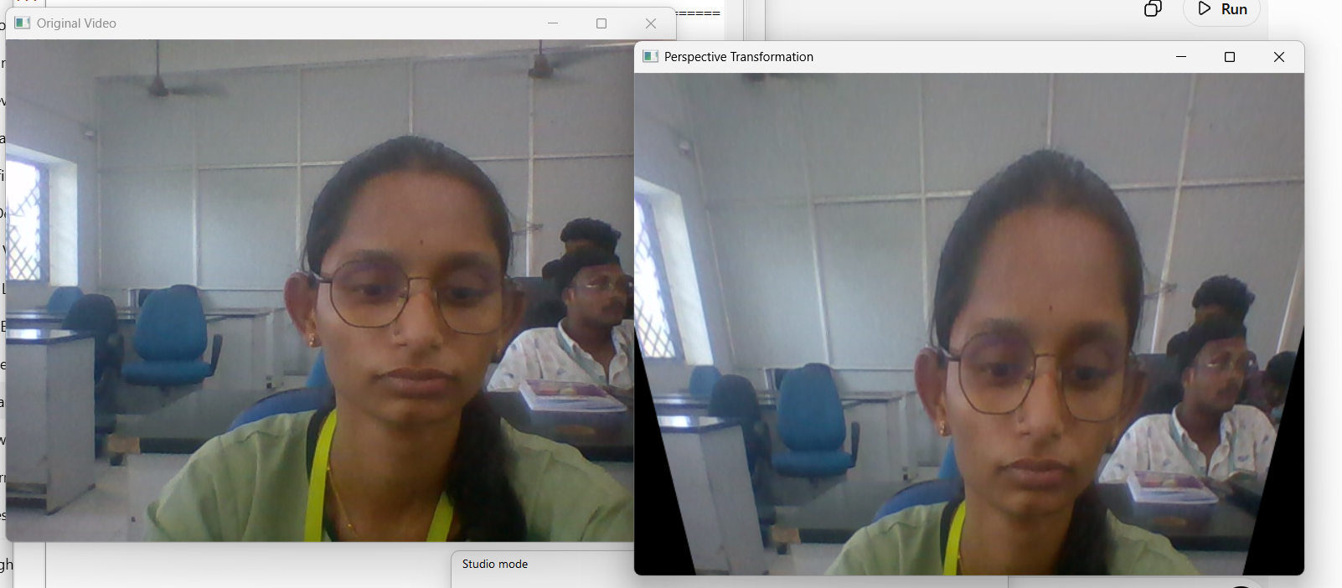
Result
The live webcam video was successfully captured using Python, and perspective transformation was applied to each frame using the OpenCV library. The transformed video was displayed successfully.

